**School Bus Types**



School buses don’t always look alike. Some are short, some have flat fronts, and others look like a shuttle van masquerading as a bus, the one thing they all share is the classic yellow color.

While there are many several types and styles of buses, all school vehicles must be manufactured to meet Federal Motor Vehicle Safety Standards for school buses. That means they all fit within 7 different classifications, the following is a sampling of the different bus types and how they are allowed to be used.

**Type A –** **Chassis type is “Cutaway”**

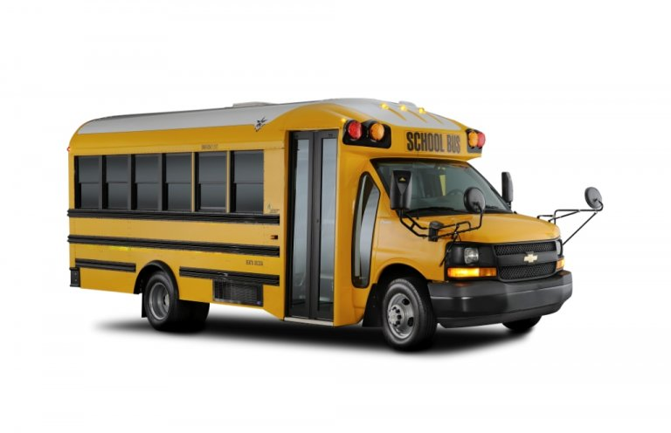

The **Type A** school buses are a bus body constructed on a cutaway front-section vehicle with a left driver’s door, they are designed to carry 10 to 25 students.  Type A school buses can be split into two sub-groups; Type A-1, having a Gross Vehicle Weight Rating (GVWR) of 10,000 pounds or less, and Type A-2, having a GVWR of 10,000 pounds or more.

**Type B – Chassis type is “Conventional”**

[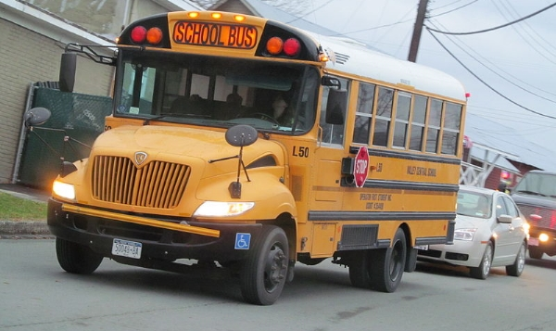](http://www.americanbussales.net/wp-content/uploads/2014/05/TypeB.jpg) The **Type B** school bus is a bus body constructed and installed upon a front-section vehicle chassis, or stripped chassis, with a GVWR of more than 10,000 pounds; these are much smaller than a standard conventional school bus and designed to carry 10 to 27 students.  Part of the engine is beneath and/or behind the windshield and beside the driver’s seat, the entrance door is then placed behind the front wheels. While usage of this type is rarer today it still meets all Federal Motor Vehicle Safety Standards and is designed for specific school district needs.

**Type C – Chassis type is “Conventional”**

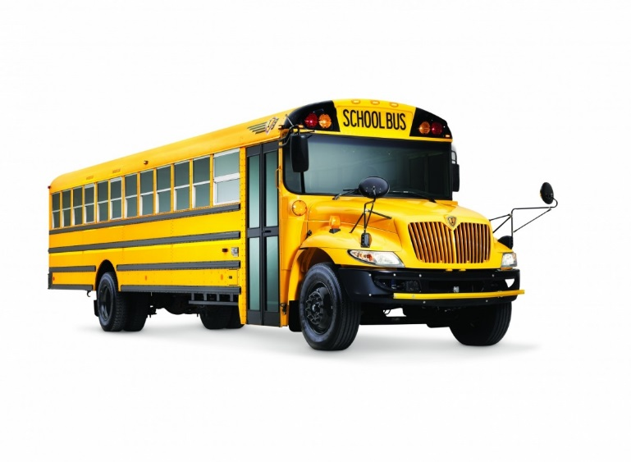

The **Type C** school bus is what most people imagine when they think of a “traditional” school bus.  A Type C school bus is often called a “conventional” bus, the body is installed upon a flat-back cowl chassis with gross vehicle weight rating of more than 10,000 pounds, designed for carrying up to 78 students.  The engine is in front of the windshield and the entrance door is behind the front wheels.

**Type D – Chassis Type is “Conventional”**

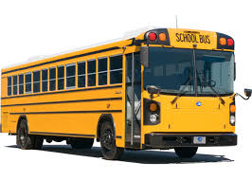 The **Type D**, or “transit-style” school bus, is a body installed upon a chassis, with a gross vehicle weight rating of more than 10,000 pounds, and designed for carrying up to 90 students.  The engine is often behind the windshield and beside the driver’s seat (referred to as forward control or “FC” (sometimes referred to as forward-engine or “FE”)), or it may be at the rear of the bus, behind the rear wheels (rear-engine or “RE”).  The entrance door is ahead of the front wheels.

**Sport Utility Vehicle – Chassis Type is “Carryall”**

A **Carryall** is a Chevrolet Suburban or similar type vehicle purchased and equipped as a school bus. **(Light Duty Vehicle)**

**Sport Utility Vehicle – Chassis Type is “SUV”**

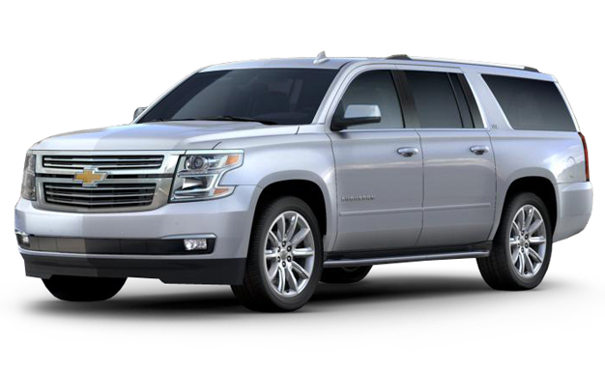

A Chevrolet Suburban or similar type vehicle purchase that is not equipped as a school bus is not categorized as a Carryall, it is categorized as an **SUV. (Light Duty Vehicle)**

**Multifunctional School Activity Buses – Chassis type is “Cutaway” (“CTL”)**

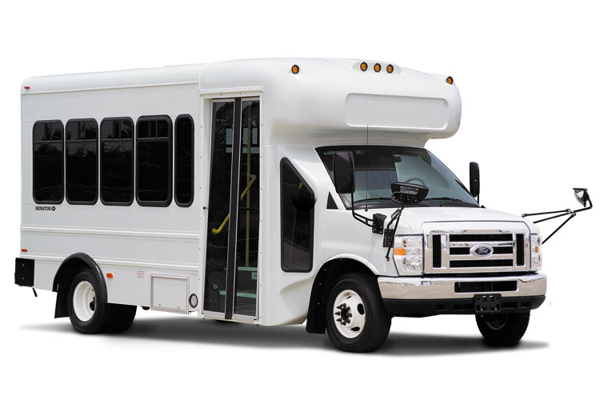All school buses sold for the purpose of transporting students between home and school must be painted the traditional yellow, if this type vehicle is purchased it must pass NYS DOT inspection for designation as a school bus. This bus is designed for carrying up to 25 passengers.

Buses not intended to transport between home and school for students from kindergarten through grade 12 don’t have to follow those rules; these buses are prohibited from use for school children in regular route bus transportation service since they are exempt from all traffic control requirements and devices including stop arms and flashing lights.

.

**Multi-Purpose Vehicle – Chassis type is “Passenger Van”**

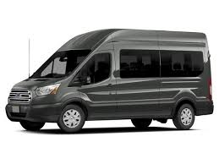

12 passenger vehicles (i.e. Ford Transit 350 Wagon or similar type vehicles) are not intended to transport between home and school for students from kindergarten through grade 12 and will not pass NYS DOT inspection without acceptable capacity modifications.  Districts should contact their NYSDOT inspector for further information prior to purchasing a vehicle of this type. **(Light Duty Vehicle)**

**Non-Conforming Vans**

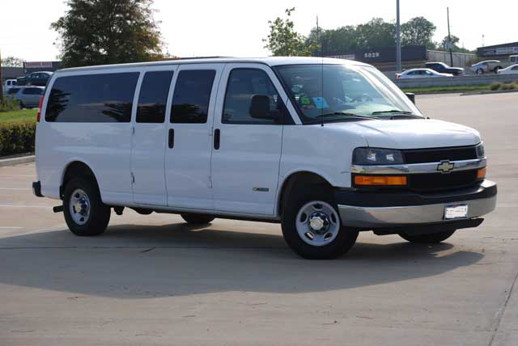

These are vehicles do not conform to the Federal Motor Vehicle Safety Standards for school buses and cannot be used to transport students.  These are typically cargo vehicles converted into 15-passenger vans with passenger seating.  These vans lack the significant safety features of even traditional passenger vehicles.